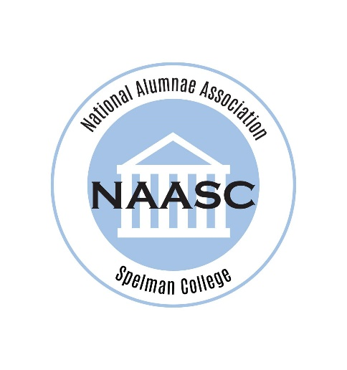
Monica Briggs Anderson, C’91 currently serves as the President of NAASC Baltimore Chapter and Chair of the Affinity Relations Committee.
Monica is a proud member of the Spelman College Class of 1991 and completed her graduate studies at Johns Hopkins University in 2016. Monica has studied at Baltimore School of the Bible and currently attends the Maryland Theological Seminary. She is the founder of Bee Excited Ministry which is a teaching ministry dedicated to bringing people together regardless of class, culture, gender, or race.
Monica is happily married to Kevin Anderson, Sr. She cherishes her role as wife and mother of Kennedy and Olivia and Bonus Mom to Kevin, Jr., Trey, and Teniera. She is the only child of Patricia Jackson Briggs and the late Perry Lee Briggs, Jr.

