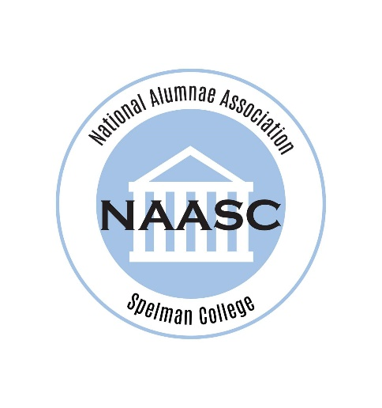
Robin Brown C’90 is currently the Northeast Regional Delegate. She has been a lifetime member of NAASC since 1998. She has been a member of several chapters since graduating but has been a member of the Washington, DC Chapter the longest including holding numerous roles on the Executive Board of the Washington, DC Chapter since 1994. At the National level she has previously held the position of NAASC Member-at-Large West and most recently was appointed as the NE Region Recording Secretary.
Robin was a Computer Science Major at Spelman College and went on to earn MBA and MS degrees from the University of Maryland College Park and several graduate certificates from the National Defense University.
Robin is a Certified Enterprise Architect with experience leading government organizations in the adoption and transformation of IT environments. Her expertise includes developing strategy and ensuring that the business, mission, application, data and technology perspectives are in line with the organization’s objectives, governance strategies, policies and standards. For the last 14 years she has supported the Defense Intelligence Agency in a number of roles and currently serves as the Program Management Lead for the Chief Technology Office. She is also a certified leadership performance coach for Federal Employees where she enjoys helping clients gain self-awareness, clarify goals, achieve their objectives, and unlock their potential.
Robin is married to the Commander Jeffrey, USN (Retd); they have three children and reside in Waldorf, MD.

